CONCORDIA UNIVERSITY
SOEN 422
Take-Home FINAL QUIZ
November 27, 2018 Due December 10, 2018

Submit this question paper with your answer following the question. Send it to the Submission box provided on the Moodle site. Please meet the deadline.
Your submission should be about 5 pages

Question 1
Write a description of Device trees and their use in the Beagle bone black embedded system.

- Give the background explaining what device trees are and the reason why they became a necessary adjunct to Linux distributions.

A device tree is essentially a file that tells the linux kernel how to configure the hardware it is using.

Initially, the different hardware specifications were built into the kernel and the boot loader would figure out what platform it was running on and pass it on to the kernel. The kernel would then configure itself based on the built in specifications.

The need for device trees arose with the proliferation of micro controllers. It was no longer possible to include the hardware specifications of all the different boards into the linux kernel and so device trees were invented as a solution. The device tree simply separates the configuration from the actual kernel so that the kernel maintainers need not worry about the different micro controller boards. Now, a user just needs to tell the boot loader what device tree they wish to use and the boot loader takes care of the rest.

Reference: http://ofitselfso.com/BeagleNotes/AboutTheDeviceTree.pdf

- Explain the complexity of the Beaglebone pin structure, and the potential difficulty of setting up the required interface functions. Refer to the multipled functions on many pins, and how the selected function must be available to software that uses it. Give an example such as SPI or PWM.

The Beaglebone black has a total of 92 pins. However, not every pin can be used for any function. Each pin is multiplexed and has up to 8 different functions. The following table shows a few pins on pin header 9 and their different functions:

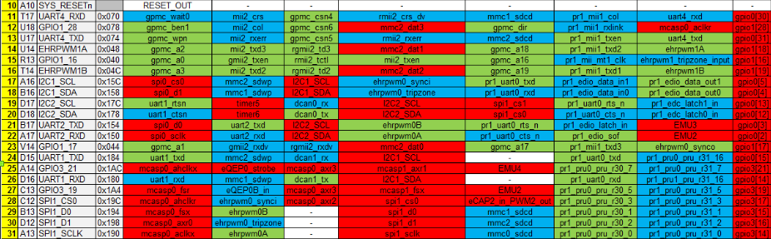

So for example, if a user needs to communicate with SPI, they need to use pins 17,18,21,22 (for SPI0) or pins 28,29,30,21 (for SPI1) because only two those set of pins provide the SPI functionality.
In addition to figuring out which pins provide the needed functionality, the user also needs to configure the pin (inside the Beaglebone’s shell) to use that functionality. For example, pin 17 (on header 9) can be used as a chip select for SPI, but it can also be used as a clock line for I²C. The easiest way to configure a pin is to use to the built-in “config-pin” utility (assuming that the universal cape is loaded). The command to make pin 17 on header 9 operate as a chip select for SPI is as follows:

config-pin P9.17 spi

There are two main problems with using “config-pin”. The first one is that a “config-pin” command needs to be run for every pin that is to be used. The second problem is that the “config-pin” commands are not persistent. In other words, upon reboot of the Beaglebone, all of the “config-pin” commands need to be run again. To make things easier, a shell script can be written with a series of desired “config-pin” commands and run at start-up automatically configure the pins. However, the proper method of configuring the pin is to use a device-tree-overlay.

- Describe the role of device tree overlays to alleviate the necessity of setting each individual pin your program may require, and give the steps required to find and install one that your software could require.

One can avoid using “config-pin” entirely by using device-tree-overlays instead. There are a number of preinstalled device trees on the Beaglebone that can be listed by typing:

ls /lib/firmware

In order to use one, it needs to be added to the file /boot/uEnv.txt .
For example, to configure pins 17,18,21,22 to use SPI (aka SPI0), the following line needs to be added to /boot/uEnv.txt :
cape_enable=bone_capemgr.enable_part=BB-SPIDEV0
In addition, the universal cape needs to be disabled by changing:
cmdline=coherent_pool=1M quiet cape_universal=enable
to:
cmdline=coherent_pool=1M
No further steps are needed. From now on, as long as SPIDEV0 is in uEnv.txt, the four SPI0 pins will always be configured for SPI.
It is also possible to install a new overlay. For example, to install Adafruit’s SPI0 overlay, it needs to be downloaded from their github repository:
wget https://raw.githubusercontent.com/adafruit/adafruit-beaglebone-io-python/master/overlays/ADAFRUIT-SPI0-00A0.dts
Then it needs to be compiled and copied to the appropriate directoy:
dtc -O dtb -o ADAFRUIT-SPI0-00A0.dtbo -b 0 -@ ADAFRUIT-SPI0-00A0.dts
cp ADAFRUIT-SPI0-00A0.dtbo /lib/firmware

- Using a very simple tree fragment example drawn from a reference, indicate how a tree specifies a desired configuration.

A device tree starts off by defining things such as compatible platforms, part-number, version, resources needed etc:

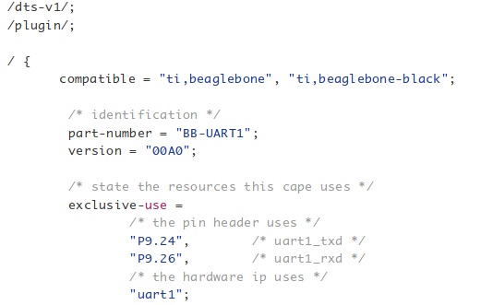
However, following sections are more important as they actually configure the pins:

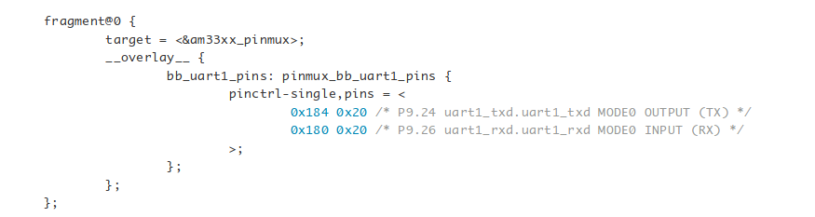
For example, this device tree overlay, configures pins 24 and 26 on header 9 to use UART. The pins are configured using the pinctrl driver. The first value (0x184) specifies the offset from the pinctrl base register address to the pinctrl device register address. The second (0x20) value specifies the contents of the device register. In this case, both pins set to MODE0 which translates to TX for pin 24 and RX for pin 26.

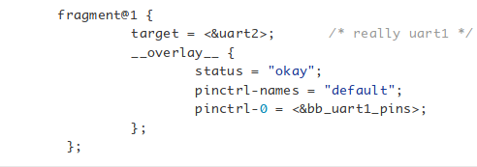

The “fragment@1” section simply enables uart by specifying uart as the target and using the pin configuration defined in the previous section.

Question 2
Write a brief explanation of why Linux is not suitable for hard real-time applications. You may include diagrams copied from references. Indicate the source. Use as an example the generation of a 2kHz square wave.
Explain how you could implement a hard real time function using a Nano board with its ATMEGA 328P computer.

In hard real-time applications, it is imperative that certain tasks (or processes) are executed before deadline. A missed deadline means that the application failed. Typically, in real-time applications, processes that interrupt the CPU are the ones that need to be serviced almost immediately. The main goal of real-time applications is to guarantee a worst case duration between the time an interrupt is triggered and the time the relevant process is serviced (the latency).

The problem with Linux is that it is a full-fledged operating system and so it is hard to say when a process will be serviced due to the many sources of latencies. On the other hand, the Arduino Nano does not have an operating system, it simply runs the program currently loaded onto it and so its behavior is much more predictable.

The Linux operating system uses spinlocks to avoid concurrency issues (two processes accessing the same resources for example). Sections of code that are protected by spinlocks can not be interrupted. In addition, there may be sections where interrupts are explicitly disabled even though they are not protected by a spinlock. As one can imagine, the use of spinlocks and the disabling of interrupts increases the latency.

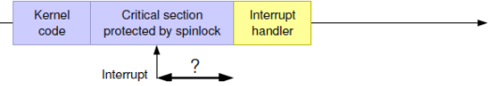

In addition, Linux does not preempt kernel processes. In other words, if a kernel process is running and is interrupted, the interrupt handler will run and wake up the interrupting process, however, the kernel process must finish before the interrupting process is serviced.

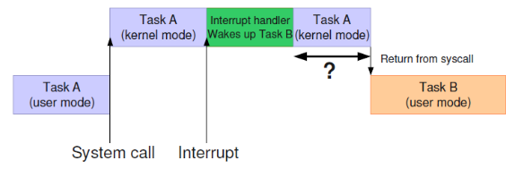
References: -http://www.cs.kun.nl/J.Hooman/DES/RealtimeLinuxBasics.pdf
-Week 13 lecture slides

Question 3
Describe in general how the PRU systems in the Beagleboneblack can be used to implement hard real time functions.

Use extracts from the code in the following reference to illustrate the phases in the creation of a C application in the PRU. Note that the function
“load_device_tree_overlay()”
is no longer valid in Debian 4.4. Explain in text what needs to be changed in this procedure and subsequently the function. Refer to week 9 slides 15 to 25.

https://github.com/rvega/bbb-pru/blob/master/apps/gpio/host.c#L2

Do not comment all the code. Explain briefly the functions and why they are needed.

The PRU is a subsystem on the Beaglebone black made specifically for the development of hard real-time functions. The Beaglebone black has two PRUs, each with their own CPU (32-bit 200MHz), allocated memory (8KB of program memory as well as 8KB of data memory), and “direct access to general I/O” (Reference: https://elinux.org/Ti_AM33XX_PRUSSv2#This_is_a_Work_In_Progress). Since the PRUs do not have an operating system, they behave in a similar way to the Arduino Nanos: they simply run the program loaded onto them. They are independent systems where one can dedicate the CPU to a single program (no preemptions due to end of time-slice or higher priority process). In addition, instructions on the PRU take known constant times which makes it possible to meet hard real-time requirements.

References:
-https://elinux.org/Ti_AM33XX_PRUSSv2#This_is_a_Work_In_Progress
-http://www.minorw.net/data/ExploringBeagleBone.pdf
-http://mythopoeic.org/bbb-pru-minimal/

Looking at the code at https://github.com/rvega/bbb-pru/blob/master/apps/gpio/host.c#L2 :

The first function called “take_over_leds()” simply attempts to open the path to the “trigger” file for the Beaglebone’s onboard leds and write “none” to it, effectively turning the leds off.
Reference: https://robotic-controls.com/learn/beaglebone/beaglebone-black-built-leds

The next function called “load_device_tree_overlay()” is supposed to load a device tree overlay. However, dynamically loading a device-tree-overlay is no longer possible in Debian 4.4. Instead, the overlay must be loaded by modifying the /boot/uEnv.txt file. In this case, the following line can be added to the uEnv.txt file to load the overlay from the code:
cape_enable=bone_capemgr.enable_part=PRU-DTO
The next function, called “init_pru_program()” is the function that activates the PRU. Inside this function, PRU is activated, interrupts are activated, the file containing the data is loaded (on the PRU) and finally the program to be executed is loaded and executed (on the PRU).
In the main function, first the PRU is inialized and set to run the program contained in “./text.bin” with the “init_pru_program()” function. After that, the program waits for the PRU to throw an interrupt. Once an interrupt is detected, the program blinks an led connected to a gpio pin until it receives a SIGINT signal after which it disables PRU and exits.

Refer to the references provided below. Do not hesitate to find other references you may think are useful.

Note that you may copy and paste any text, diagram, or tree segment you think is useful, but in all cases use standard referencing notation, including quotes for pasted text segments.

Suggested References

Device Trees
- Introduction to device trees
http://ofitselfso.com/BeagleNotes/AboutTheDeviceTree.pdf

2. Introduction to cape manager and slots. Note again that you can no longer load an overlay from a program. You must edit Env.txt and then reboot. The rest of the article is good
http://www.raspberry-pi-geek.com/index.php/Archive/2014/03/Capemgr-keeps-track-of-the-BeagleBone-Black-s-expansion-boards-known-as-capes/(offset)/2

3. Excellent example explaining an overlay 2018
https://learn.adafruit.com/introduction-to-the-beaglebone-black-device-tree/device-tree-overlays

4. Basic concepts, advanced detail examples, Sections up to 3.1 could be useful
http://www.devicetree.org/Device_Tree_Usage

Real Time
http://www.cs.kun.nl/J.Hooman/DES/RealtimeLinuxBasics.pdf

Week 13 Moodle: Reference RT UNIX(free electrons site)

PRU
Architecture
https://elinux.org/Ti_AM33XX_PRUSSv2

intro/slide set
https://elinux.org/images/1/1c/Birkett--enhancing_rt_capabilities_with_the_pru.pdf

Derek Molloy page 503
http://www.minorw.net/data/ExploringBeagleBone.pdf ←has stuff for question 2 (2khz wave)

Good PRU discussion
http://mythopoeic.org/bbb-pru-minimal/

Run C programs on the PRU
http://www.righto.com/2016/09/how-to-run-c-programs-on-beaglebones.html

